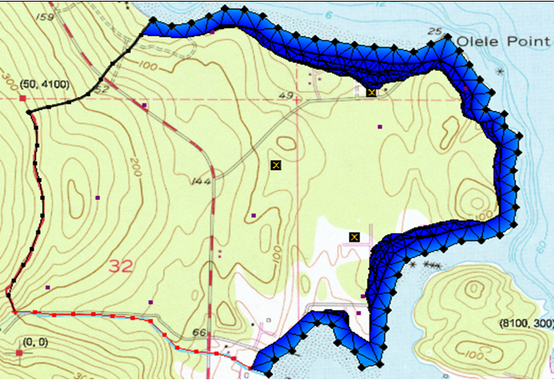

GMS 10.9

GMS 10.9 Tutorial

FEMWATER – Transport Model

Build a FEMWATER model to simulate salinity intrusion

Objectives

This tutorial demonstrates building a FEMWATER transport model using the conceptual model approach. It will review running the model and examining the results.

Time

* 20–30 minutes

Required Components

* FEMWATER
* Geostatistics
* GMS Core
* Subsurface

Prerequisite Tutorials

* FEMWATER – Flow Model

|  |
| --- |
| 1 Introduction 2  1.1 Getting Started 3  2 Opening the Flow Model 3  3 Building the Transport Model 4  3.1 Turning On the Transport Option 4  3.2 Defining the Boundary Conditions 4  4 Converting the Conceptual Model 5  5 Selecting the Analysis Options 5  5.1 Run Options 5  5.2 Time Control 6  5.3 Initial Conditions 6  5.4 Output Control 6  6 Saving and Running the Model 6  6.1 Animating the Freshwater Surface 7  7 Conclusion 7 |

# Introduction

FEMWATER is a three-dimensional finite element groundwater model designed for simulating both flow and transport in saturated and unsaturated zones. It can also simulate coupled flow and transport to address density-dependent problems, such as salinity intrusion.

This tutorial focuses on modeling a small coastal aquifer site, which contains three production wells, each pumping at a rate of 2,830 m3/day (Figure 1). The model features two no-flow boundaries: one on the upper left, representing a parallel flow boundary, and another on the left, where a high bedrock elevation causes the aquifer to thin. A stream at the lower left provides a specified head boundary, while the coastal boundary is represented by a specified head condition. The coastline arc is assigned a specified concentration boundary of 19 mg/liter of salt.

The site’s stratigraphy consists of an upper and lower aquifer. The upper aquifer has a hydraulic conductivity of 3 m/day, while the lower aquifer has a hydraulic conductivity of 9 m/day. The wells extend into the lower aquifer. Recharge to the aquifer occurs at a rate of about one foot per year.

The objective of this tutorial is to develop a transport model of the site to simulate salinity intrusion from the coastline.

This tutorial will cover the following topics:

* Importing an existing FEMWATER flow model
* Mapping the conceptual model to a FEMWATER simulation
* Selecting analysis options
* Running FEMWATER
* Creating and viewing an animation of the results



Figure 1 Site to be modeled with FEMWATER

## Getting Started

Do the following to get started:

1. If GMS is not running, launch GMS.
2. If GMS is already running, select *File* | **New** to ensure the program settings are restored to the default state.

# Opening the Flow Model

Before setting up the FEMWATER transport simulation, a FEMWATER solution must first be established to serve as the flow field for the transport simulation. To save time, a previously created FEMWATER simulation can be imported.

1. Click **Open** File:Open Macro.svg to bring up the *Open* dialog.
2. Select “Project Files (*.gpr)” from the *Files of type* drop-down.
3. Browse to the *femwater-transport\femwater-transport* directory and select “femmod.gpr”.
4. Click **Open** to import the project file and close the *Open* dialog.
5. **Frame** File:Frame Macro.svg the project.

The main Graphics Window should appear similar to Figure 2.

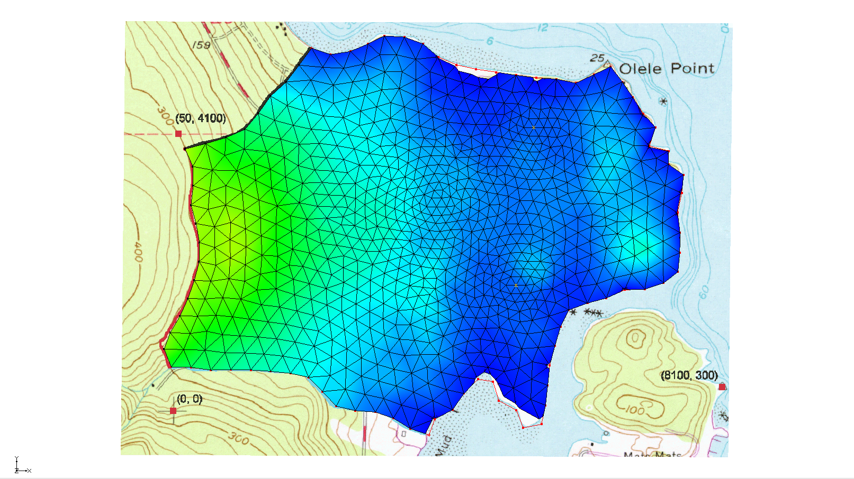

Figure 2 Initial view of the imported project

# Building the Transport Model

The purpose of this model is to simulate salinity intrusion by assigning a salt concentration to the coastline arc. This concentration can be directly applied to the arc within the conceptual model.

## Turning On the Transport Option

1. In the Project Explorer, right-click on “https://www.xmswiki.com/images/thumb/8/8c/Map_Folder.svg/60px-Map_Folder.svg.png Map Data” and select **Expand All**.
2. Right-click on “File:Conceptual Model Icon.svg femmod”and select **Properties…** to open the *Conceptual Model Properties* dialog.
3. In the table, turn on *Transport*.
4. Click **OK** to exit the *Conceptual Model Properties* dialog.
5. Right-click on “File:Coverage Active Icon.svg femwater” and select **Coverage Setup…** to open the *Coverage Setup* dialog.
6. In the *Sources/Sinks/BCs* list, turn on *Transport BC*.
7. Click **OK** to close the *Coverage Setup* dialog.

## Defining the Boundary Conditions

Assign boundary conditions to the coastline arc.

1. Select “File:Coverage Active Icon.svg femwater” to make it active.
2. Using the **Select Arcs** File:GMS Select Arc Tool.svg tool, double-click on the coastline arc to bring up the *Attribute Table* dialog.
3. In row *4* in the table, select “spec. conc.” from the drop-down in the *Transport bc* column.
4. Enter “19.0” in the *Conc*. *(mg/l)* column (scroll to the right, if needed).
5. Click **OK** to close the *Attribute Table* dialog.

# Converting the Conceptual Model

Now it is possible to convert the conceptual model to the 3D mesh model. This will assign all of the boundary conditions using the data defined in the feature objects.

1. In the Project Explorer, right-click on “File:Conceptual Model Icon.svg femmod” and select *Map To*| **FEMWATER** to bring up the *Map → Model* dialog.
2. Click **OK** to accept the defaults and close the *Map → Model* dialog.

A set of symbols should appear indicating that the boundary conditions have been assigned (Figure 3).

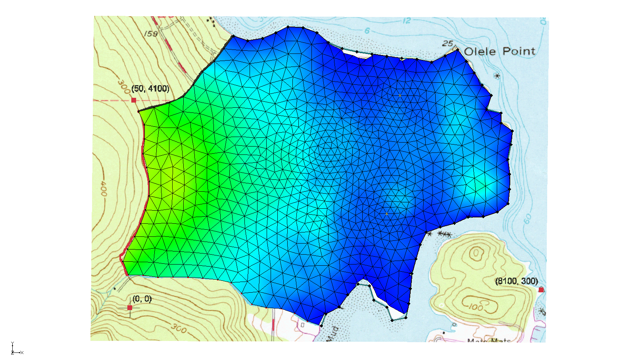

Figure 3 Coastline arc shows the boundary conditions

# Selecting the Analysis Options

Next, select the analysis options.

## Run Options

First, indicate a steady-state flow simulation.

1. Select *FEMWATER |* **Run Options…** to open the *FEMWATER Run Options* dialog.
2. For the *Type of simulation (OP1)* option, select “Transport only (1)”.
3. For the *Quadrature (IQUAR)* option, select “Nodal/Nodal (11)”.
4. Click **OK**to close the *FEMWATER Run Options* dialog.

## Time Control

Second, set the FEMWATER time control options.

1. Select *FEMWATER |* **Time Control…** to open the *FEMWATER Time Control* dialog.
2. Enter “360.0” as the *Maximum simulation time*.
3. Enter “30.0” as the *Constant time step*.
4. Click **OK** to close the *FEMWATER Time Control* dialog.

## Initial Conditions

Third, set the FEMWATER initial conditions.

1. Select *FEMWATER |* **Initial Conditions…** to open the *FEMWATER Initial Conditions* dialog.
2. In the *Files* section, click the **Open** File:Open Macro.svg button to the right of *Flow (press. head) (FLPH)* to bring up the *Open* dialog.
3. Select “Pressure Head Files (*.phd)” from the *Files of type* drop-down.
4. Browse to the *femwater-transport\femwater-transport\femmod_FEMWATER* directory and select “femmod.phd”.
5. Click **Open** to select the file and exit the *Open* dialog.
6. In the section on the right, under *Flow file format (IVFILE)*, select *Binary (1)*.
7. Click **OK** to close the *FEMWATER Initial Conditions* dialog.

## Output Control

Finally, have GMS create the concentration dataset solution file.

1. Select *FEMWATER |* **Output Control…** to open the *FEMWATER Output Control* dialog.
2. In the *Save options (OC4)* section, turn on *Save concentration (.con) file (5)*.
3. Click **OK** to close the *FEMWATER Output Control* dialog.

# Saving and Running the Model

To save and run the model:

1. Click **Save**File:Save Macro.svg to save the project file with all of the new settings.
2. Select *FEMWATER |* **Run FEMWATER…** to bring up the *FEMWATER* model wrapper dialog.

The *FEMWATER* model wrapper dialog should appear showing information on the progress of the model convergence. The model should converge within a few minutes.

1. When the model converges, turn on *Read solution on exit* and click **Close** to close the *FEMWATER* model wrapper dialog.

## Animating the Freshwater Surface

To animate the freshwater isosurface over time:

1. Right-click on “File:3D Mesh Folder.svg 3D Mesh Data” and select **Expand All**.
2. Under “File:Generic Folder Locked.svg femmod (FEMWATER)”, select “File:Dataset Points Active.svg concentration”.
3. Select *Display |* **Animate…** to bring up the *Options* page of the *Animation Wizard* dialog.
4. Click **Next >** to accept the defaults and go to the *Datasets* page of the *Animation Wizard* dialog.
5. Click **Finish** to close the *Animation Wizard* dialog and create the animation. This process may take a minute or so, depending on the speed of the computer.

Open a media player application outside of GMS and play the MP4 file. Observe how the freshwater surface is influenced by the pumping wells (Figure 4). After viewing, close the media player and return to GMS.

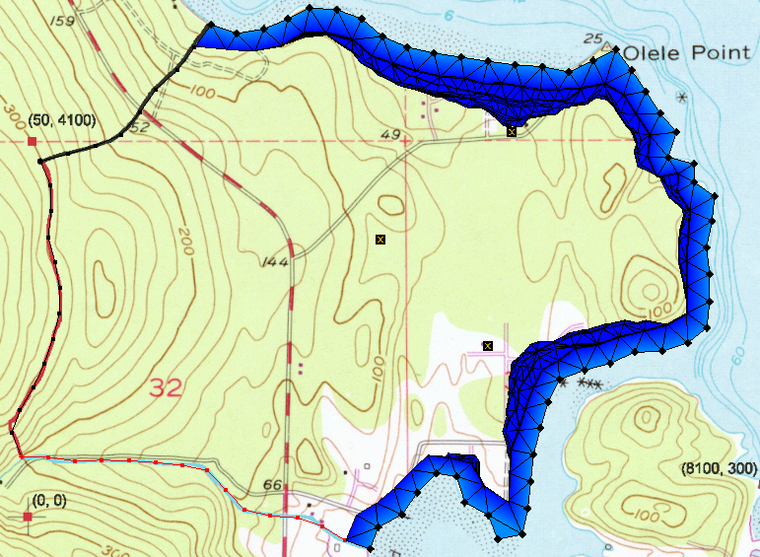

Figure 4 The last frame of the animation

# Conclusion

This concludes the “FEMWATER – Flow Model” tutorial. The following key topics were discussed and demonstrated:

* Setting up a FEMWATER transport model
* Reviewing the results with animation